1. HR Manager login with his credentials then clicks on “Associate Separation” from “Associate Exit” section.

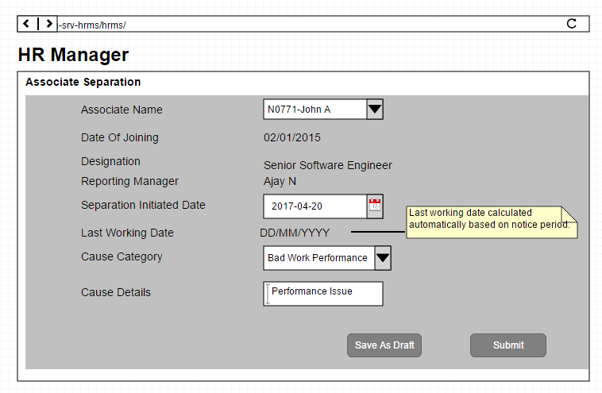

1. Department head login with his credentials System displays all the “Separated” Associate requests.

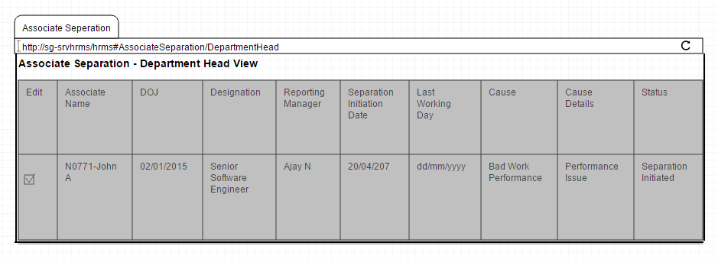

1. When Department head selects appropriate associate , System displays the details of the selected Associate

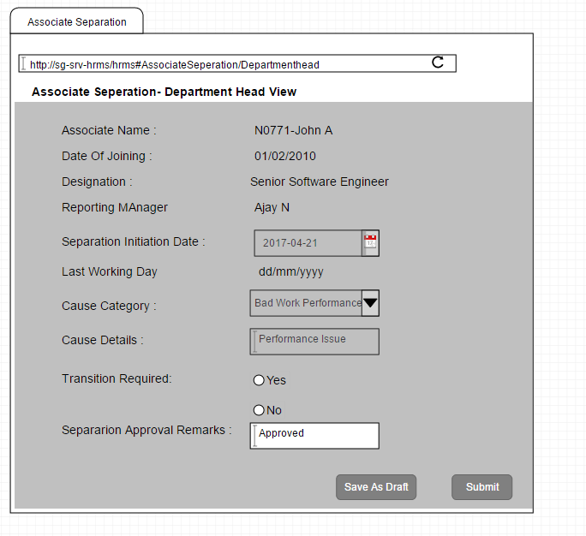

1. Reporting Manager login with his credentials System displays all the “Separated” Associate requests (Approved)

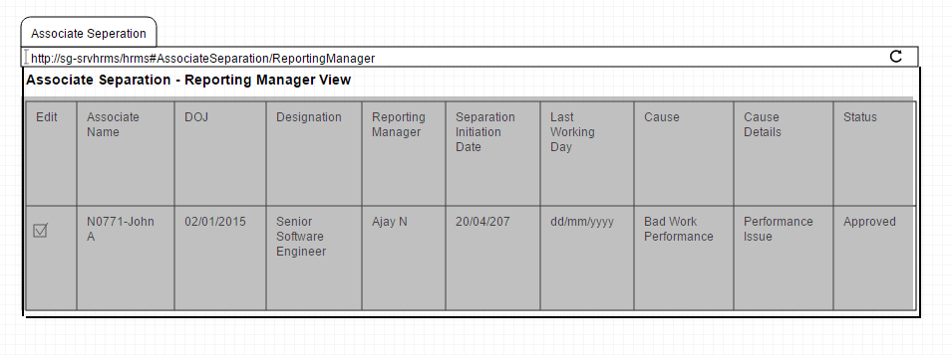

1. Reporting Manager Clicks on appropriate associate will display associate details with “Transition Plan” Link.

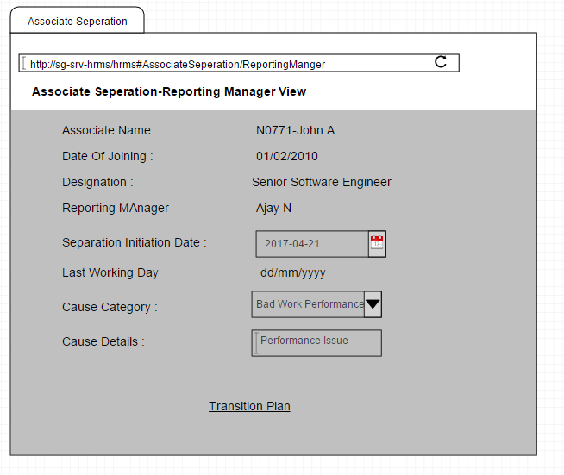

1. Reporting Manager clicks on Transition Plan, Navigates to the Transition submit form.

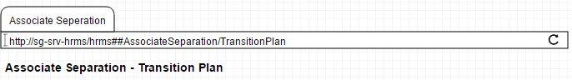 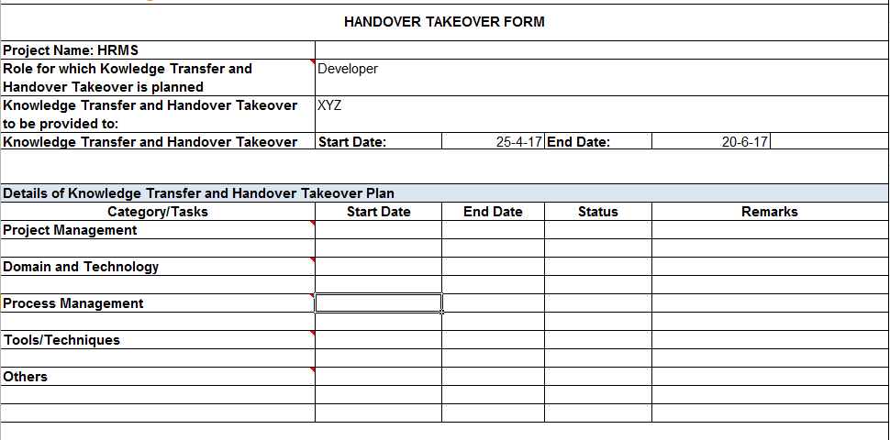

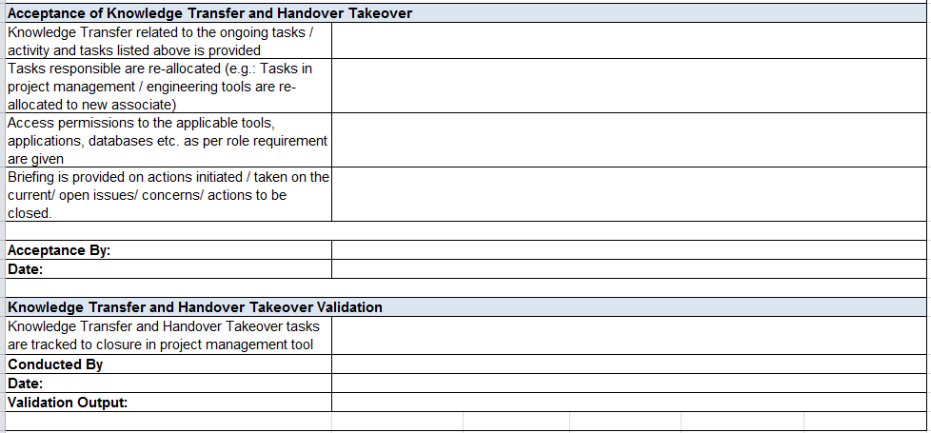

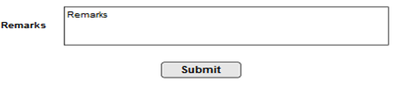

1. Associate login with credentials, has to provide the inputs for each and every task in the transition plan and clicks submit.



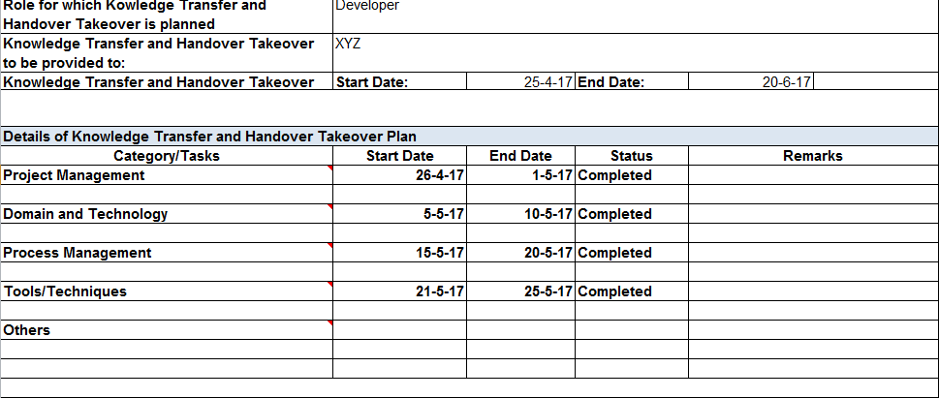





1. IT Department Login, System displays all the “Separated” Associate(Approved) details to IT Department

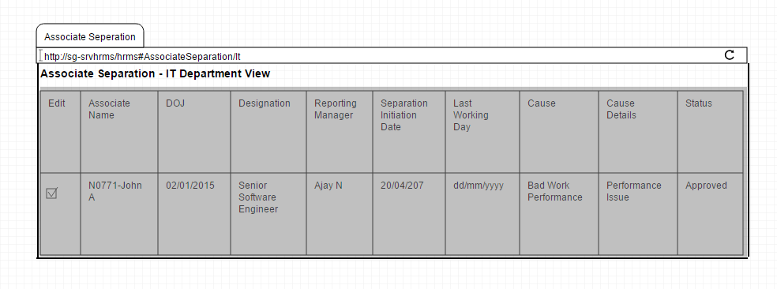

1. Clicks on particular Associate Separation details. System displays the details of the selected Associate }

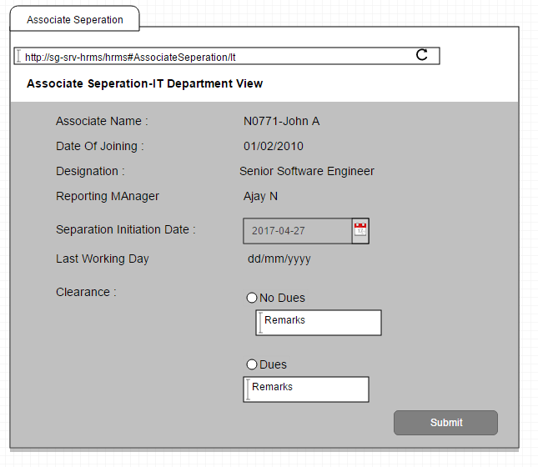

1. IT Department Login, System displays all the “Separated” Associate(Approved) details to IT Department

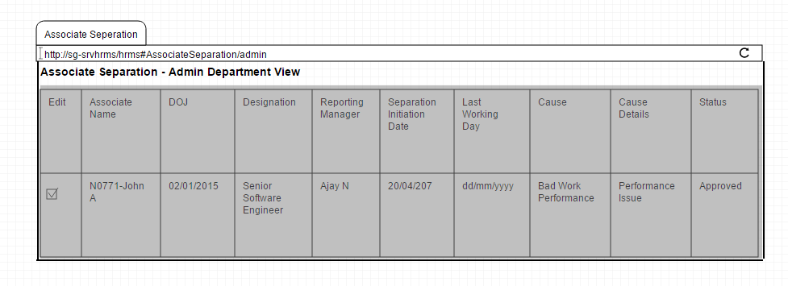

1. Clicks on particular Associate Separation details. System displays the details of the selected Associate

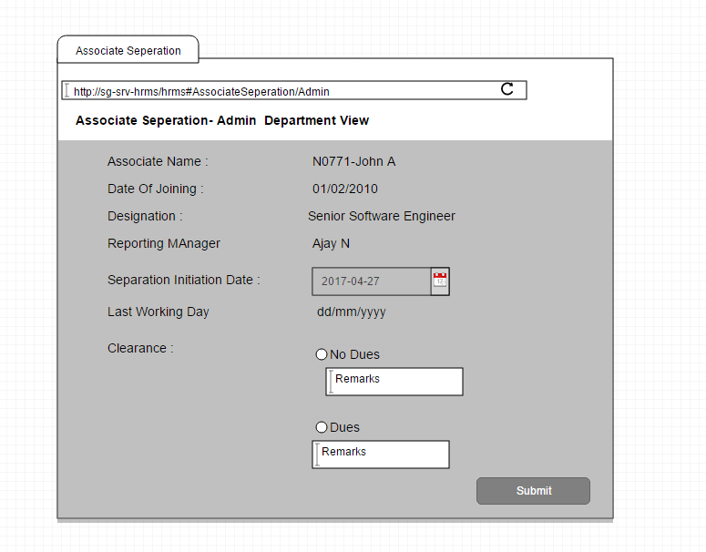

1. Finance Department Login, System displays all the “Separated” Associate (Approved) details to Finance Department.

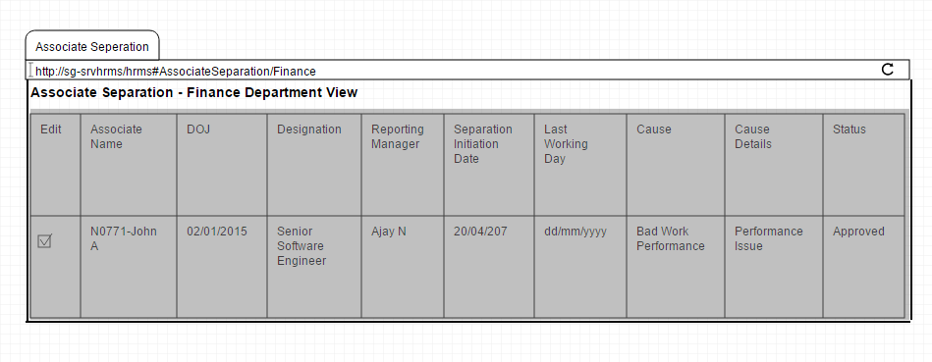

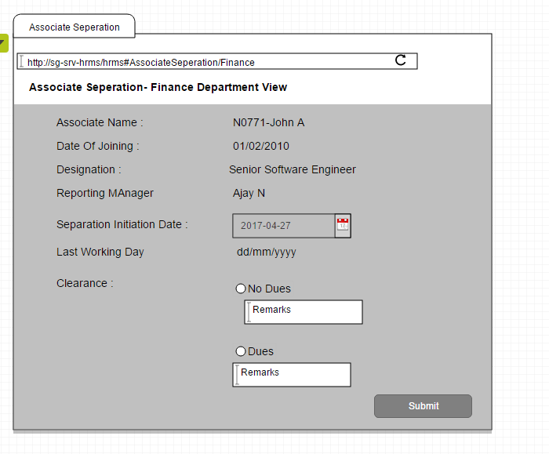

1. HR Login, System displays all the “Separated” Associate (Approved) details to Finance Department.

